## Vi Editor – Assignment

1. Invoke the vi editor with a filename (which is to be created) .



1. Type a few lines(at least 10) in the editor. Let one or more lines contain the words given below.

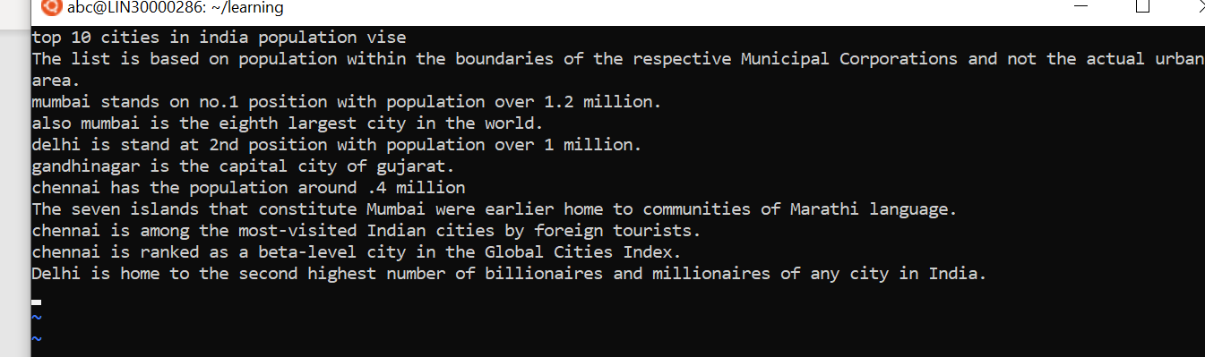

* delhi mumbai chennai Mumbai

1. Save the file without exiting the editor



1. Navigate quickly to the beginning & end of the file





1. Delete first two lines & copy it after the last line.

* By using 2**dd** and then go to last line and paste using **p**

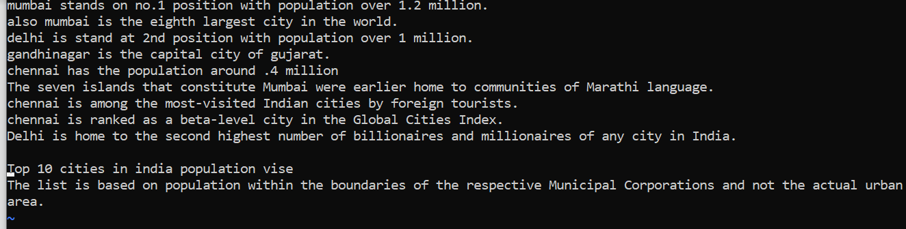

1. Now Copy the last two lines & paste them before the first line.

Using 3yy and p

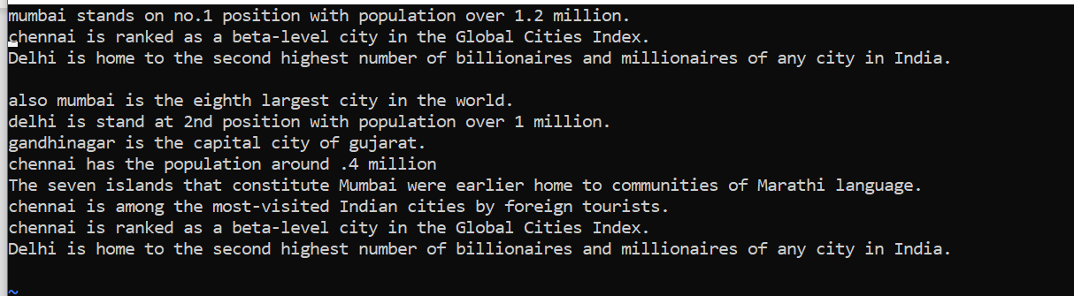

1. Combine last two lines of the file in a single line.

* **position the cursor anywhere on the last line and press J to join the two lines**.



1. How will you insert a line before the first line? (Hint : Find such an option in the tutorial document)

* Use :1 to go to the first line
* Use ctr + V to enter the visual mode
* Hit shift + Enter to shift position and type the line you want to insert

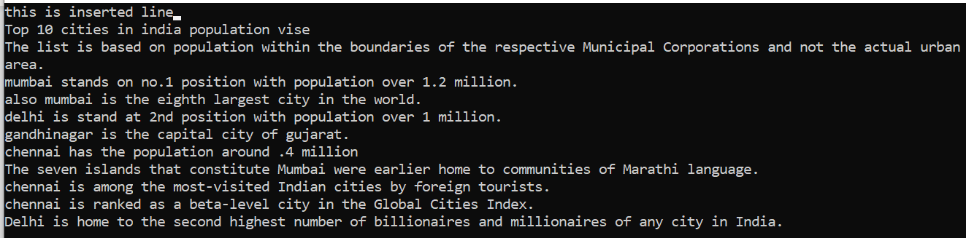

1. How will you paste a yanked buffer before the current line?

* By using **P**

1. Search the document for a string “delhi”



1. Replace a single occurrence of “delhi” with “Mumbai”

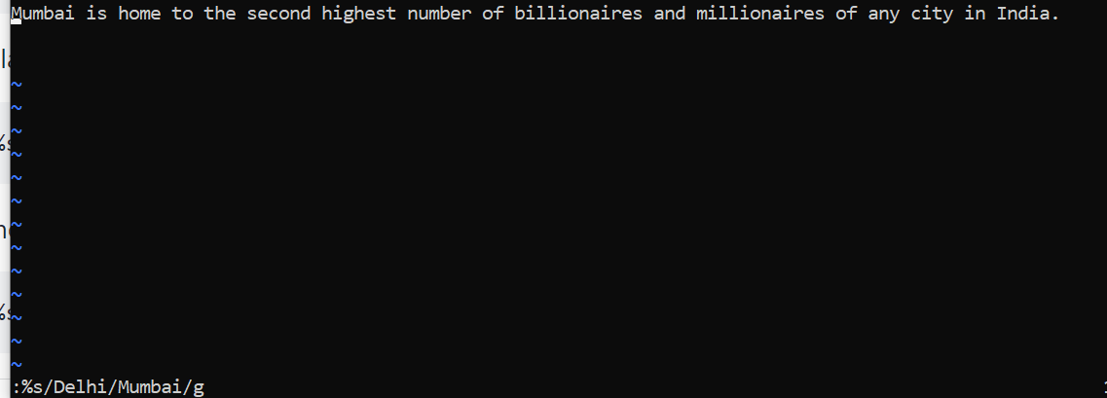

1. Replace all occurrences of “delhi” on a particular line with “Mumbai” using one command.

* **6s/delhi/Mumbai/g**

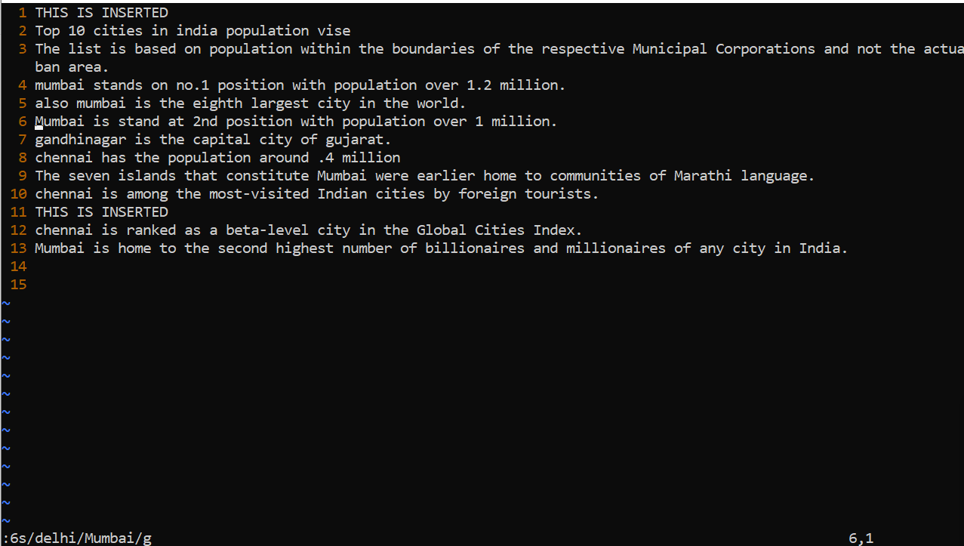

1. Replace “delhi” with “mumbai” for the entire document using one command.

* **.,$s/delhi/Mumbai/g**

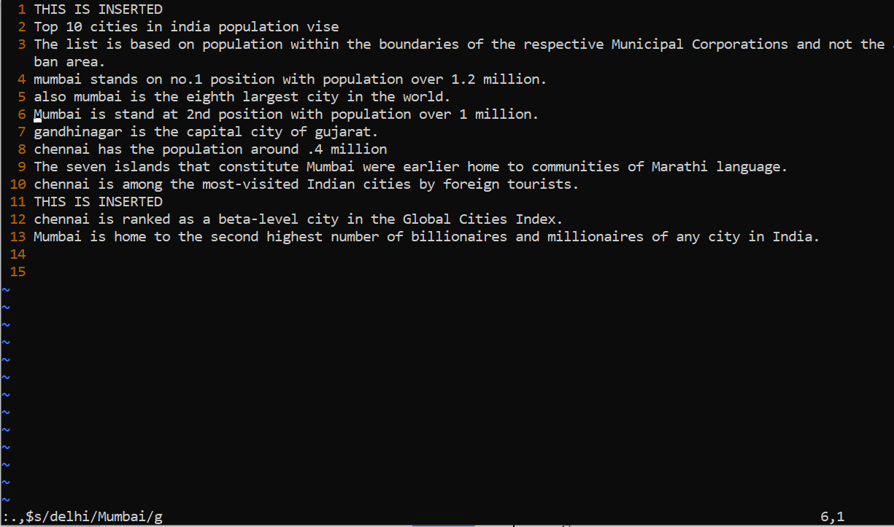

1. Replace all occurrences of “delhi” with “mumbai” for part of a document (e.g. line number 13 to 37).

* **13,37s/delhi/Mumbai**

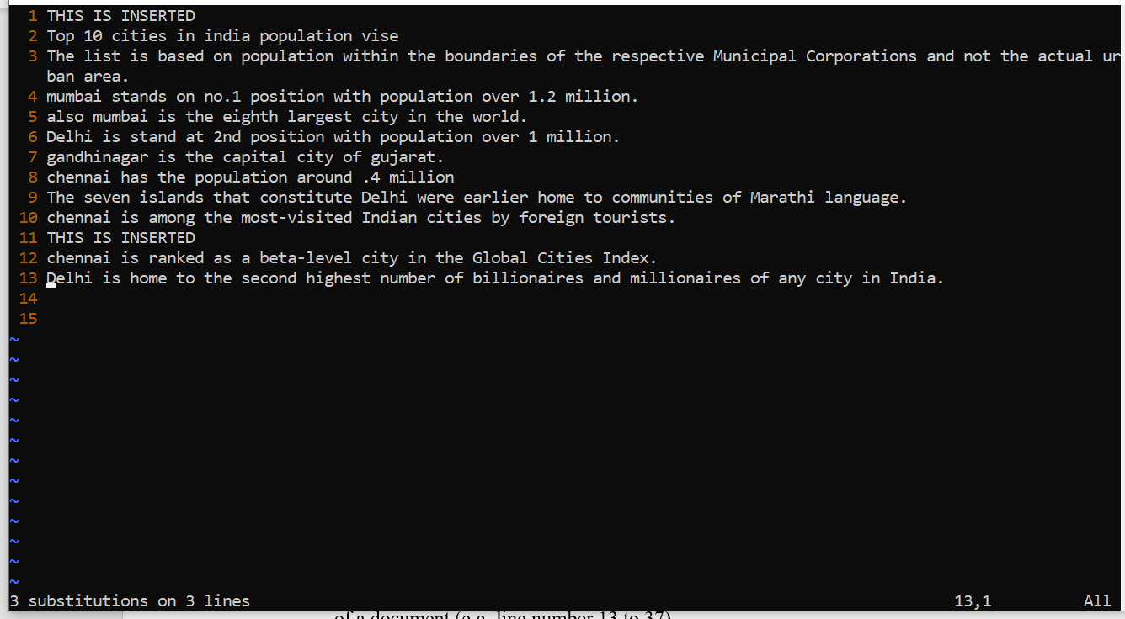

1. Undo the above command

On command mode hit **u**

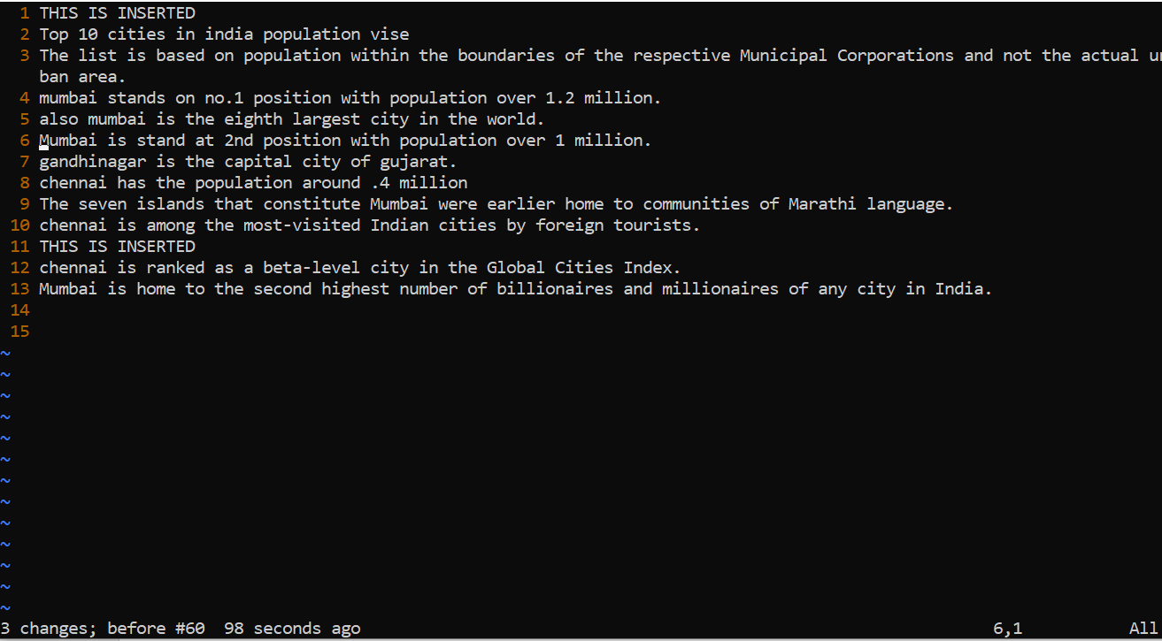

1. Replace only the first occurrence of “delhi” with “mumbai” in each line, for part of a document (e.g. line number 13 to 37).

* **13,37s/<delhi>/Mumbai/g**
* 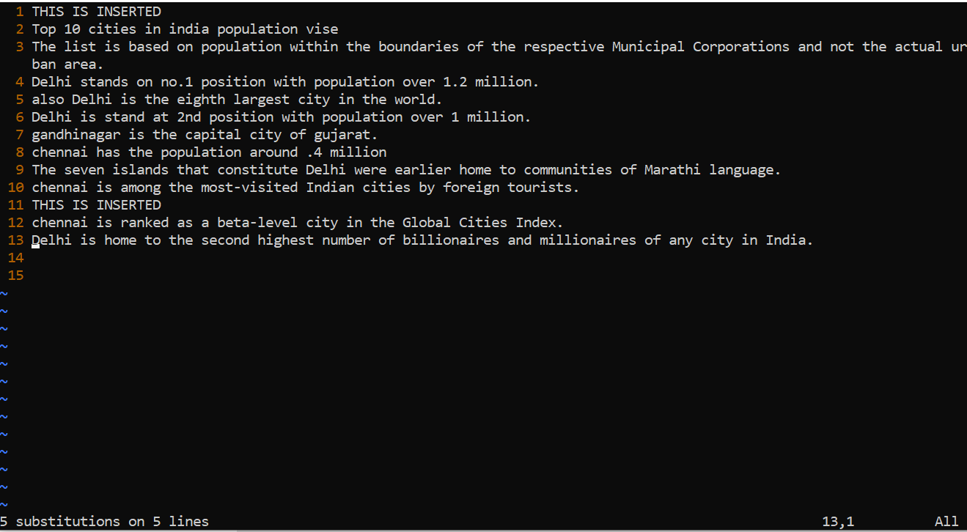

1. Undo the above comment. Redo it. Undo it again.

* Press **u**
* Hold **Ctrl and press r**
* Press **u**

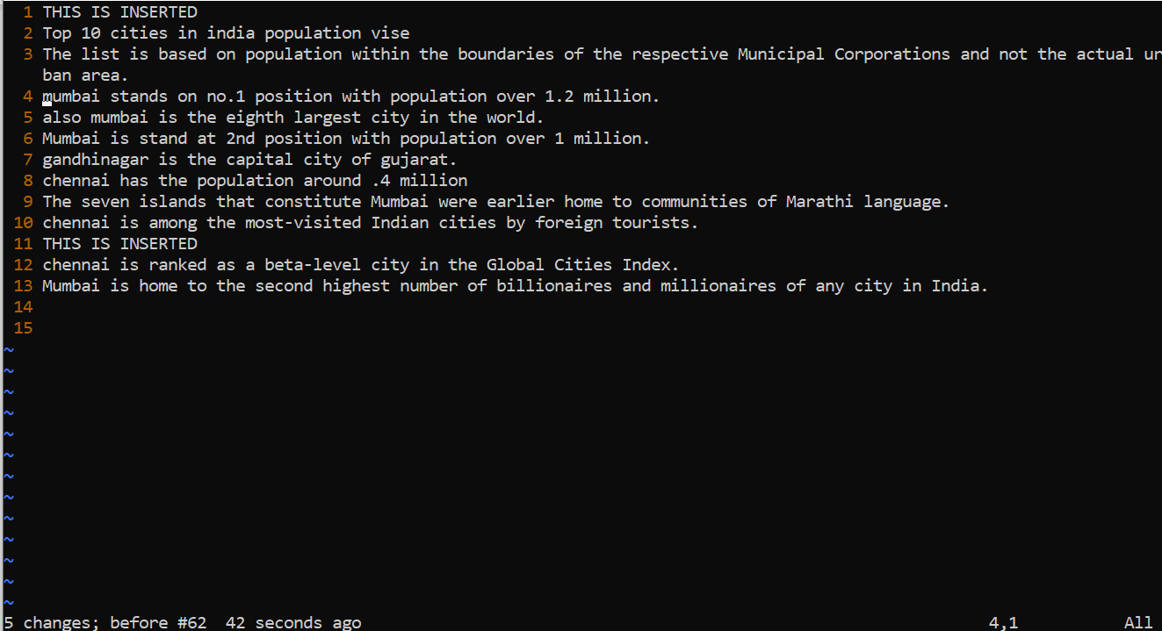

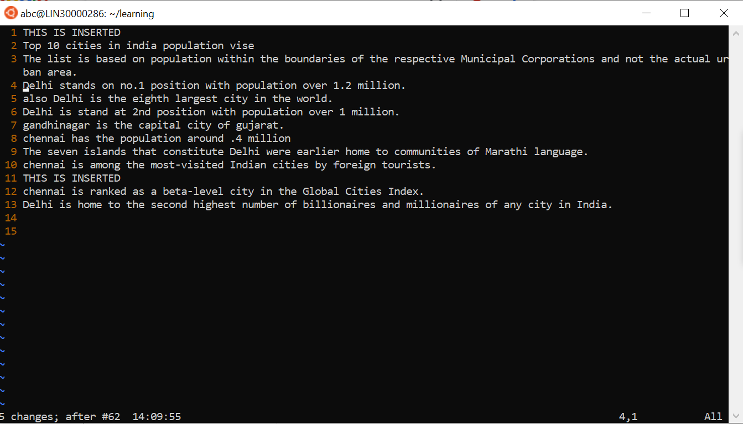

1. Replace all occurrences of “delhi” with “mumbai” for complete file interactively.

* **.,$s/delhi\|Delhi/Mumbai/g**
* 

1. Search for a word backwards. Loop through all matches.

* **?Delhi**

1. Search for a word forwards. Loop through all matches

* **/Delhi**

1. Join two lines together.

* **position the cursor anywhere on the last line and press J to join the two lines**

1. Enable line numbering and then disable it

* Set nu

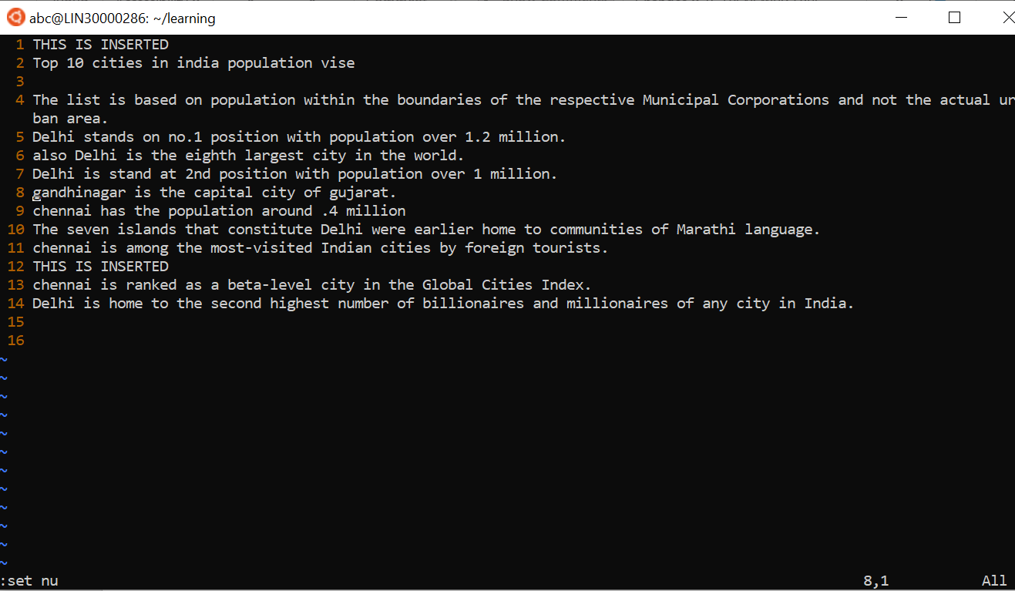

1. Make the search case insensitive

* **:set ignorecase**

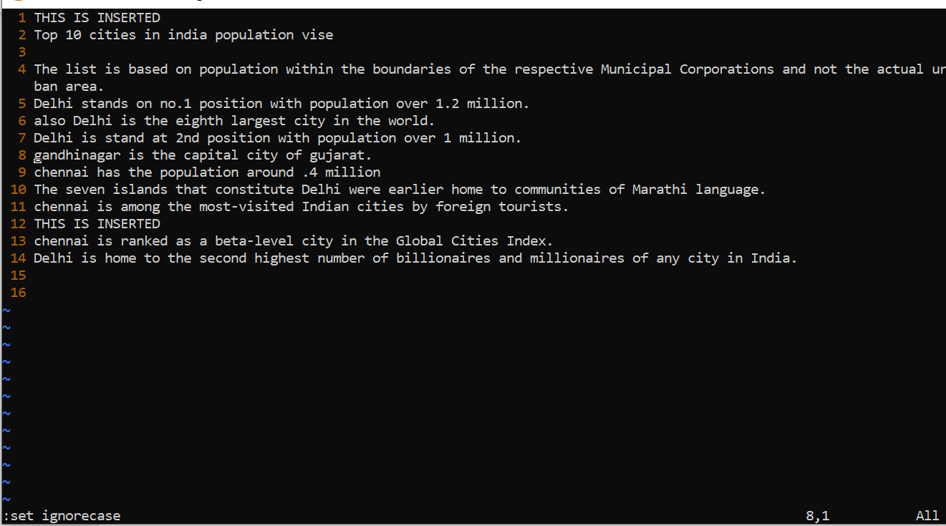

1. Delete 4 lines (and then paste them somewhere else)

* By using **4dd**

And press **p** to paste somewhere else

* 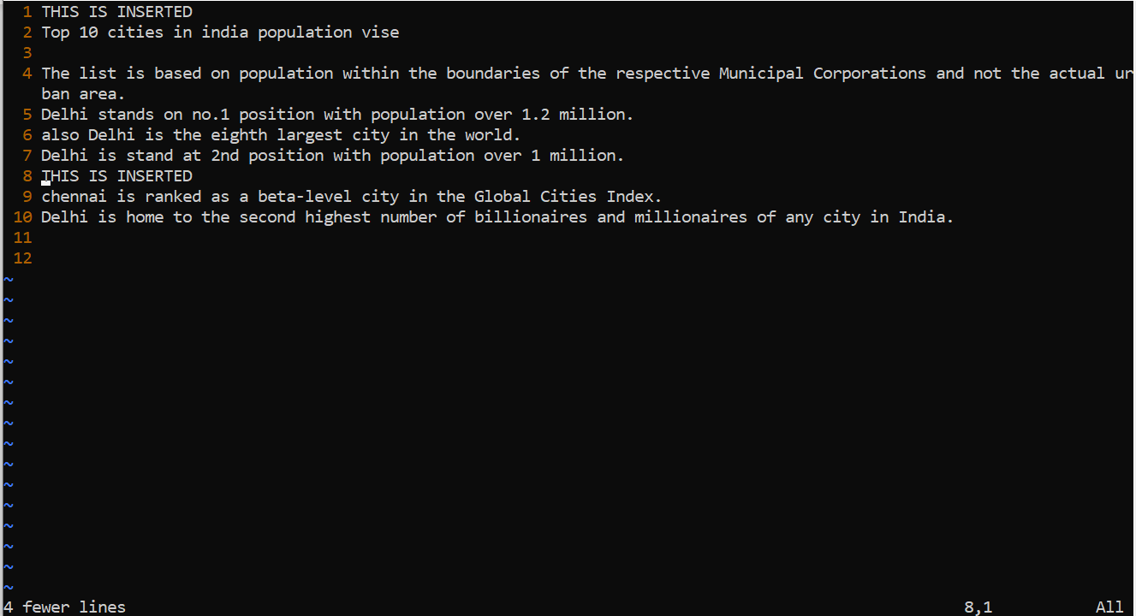

1. What is the command to delete part of the line starting from the current cursor position?
   * Press **Esc** come to command mode
   * press **v** enter visual mode
   * **Shift + g** "selects everything from current position to EOF"
   * **DEL** "delete selected"
2. What is the command to delete the current word?

* **Dw command**